

NCICB

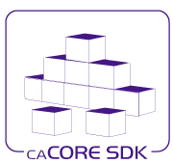
caCORE SDK
Generated System Detail Design

Version No: 1.1
Last Modified: 08/17/2006

Author: Daniel Dumitru
Team: caCORE SDK
Client: National Cancer Institute - Center for Bioinformatics,
National Institutes of Health,
US Department of Health and Human Services

This document was prepared NCI Center for Bioinformatics
Pursuant to the caCORE Software Development Kit (SDK)
Project (REF: Solicitation No. S06-234).

Document History

Document Location
The most current version of this document is located in CVS under cacoresdk/Project/SDK v3.2/Development/Design.

Revision History
Version Number | Revision Date | Author | Summary of Changes
1.0 | 07/11/06 | Daniel Dumitru | Initial draft
1.1 | 07/14/06 | Satish Patel | Formatting, grammar changes
1.2 | 07/19/06 | Daniel Dumitru | Added Persistence Detail Design section
1.3 | 07/26/06 | Daniel Dumitru | Added Query Detail Design section
1.4 | 08/23/06 | Daniel Dumitru | Updated per Document Review(s)

Review
Name | Team/Role | Version | Date Reviewed | Reviewer Comments
Satish Patel |  | 1.1 | 07/14/2006 | Formatting, grammar changes
Steve Hunter | QA | 1.2 | 08/17/2006 | Formatting, grammar

Related Documents
More information can be found in the following related documents:

Document Name

Table of Contents
Document History 2
0.1 Document Location 2
0.2 Revision History 2
0.3 Review 2
0.4 Related Documents 2
Table of Contents 3
Table of Figures 5
1. Introduction 6
1.1 Purpose 6
1.2 Intended Audience 6
1.3 Scope 6
1.4 Overview 6
1.5 Definitions, Acronyms, and Abbreviations 6
2. Exception Handling Detail Design 7
2.1 Current Design - Problem Scenario 7
2.1.1 Analysis of Current caCORE SDK Exception Class Definitions and Usage 7
2.1.2 Problems with the ApplicationException Class 8
2.2 Proposed Exception Handling Enhancements 10
2.2.1 Introduction of More Specific Exception Classes 10
2.2.2 Code Changes to Classes that Use (Throw) ApplicationException 12
3. Query Detail Design 13
3.1 The Query Interfaces within the caCORE SDK Tiered Architecture 13
3.2 Supported SDK Query Types 14
3.2.1 Simple Search Query Type 15
3.2.2 Nested Search Query Type 16
3.2.3 Detached Criteria Query Type 16
3.2.4 HQL Criteria Query Type 16
3.3 Supported SDK Query Interfaces 17
3.4 Java API 17
3.4.1 gov.nih.nci.system.applicationservice.ApplicationServiceProvider 19
3.4.2 gov.nih.nci.system.comm.client.ApplicationServiceClientImpl 20
3.4.3 gov.nih.nci.system.comm.server.ApplicationServiceServerImpl 21
3.4.4 gov.nih.nci.system.applicationservice.impl.ApplicationServiceImpl 22
3.4.5 gov.nih.nci.system.applicationservice.impl.ApplicationServiceBusinessImpl 23
3.4.6 gov.nih.nci.common.util.ListProxy 24
3.5 Web Services API 26
3.5.1 Web Services Client 27
3.5.2 Axis Web Services API 28
3.5.3 gov.nih.nci.system.webservice.WSQuery 28
3.5.4 gov.nih.nci.system.webservice.WSTransformer 29
3.6 XML-HTTP API 30
3.6.1 gov.nih.nci.system.proxy.HTTPQuery 31
3.6.2 gov.nih.nci.common.util.HTTPUtils 34
4. Persistence Tier Detail Design 36
4.1 The Persistence Tier within the caCORE SDK Tiered Architecture 36
4.2 Base Delegate Query Interface 37
4.2.1 gov.nih.nci.system.applicationservice.impl.ApplicationServiceBusinessImpl 38
4.2.2 gov.nih.nci.common.net.Request 39
4.2.3 gov.nih.nci.common.net.Response 40
4.2.4 gov.nih.nci.system.delegator.BaseDelegate 41
4.2.5 gov.nih.nci.system.servicelocator.ServiceLocator 41
4.2.6 gov.nih.nci.system.dao.DAOFactory 42
4.2.7 gov.nih.nci.system.dao.ORMDAOFactory 43
4.2.8 gov.nih.nci.system.dao.impl.orm.ORMDAOImpl 44
4.2.9 gov.nih.nci.system.dao.impl.orm.ORMConnection 44
4.2.10 gov.nih.nci.common.util.NestedCriteria2HQL 45
4.3 Writable DAO Create, Read, Update, Delete Interface 46
4.3.1 gov.nih.nci.system.applicationservice.impl.ApplicationServiceImpl 48
4.3.2 gov.nih.nci.system.dao.WritableDAO 49
4.3.3 gov.nih.nci.system.servicelocator.ServiceLocator 50
4.3.4 gov.nih.nci.system.dao.impl.orm.ORMConnection 50
5. Configuration/Deployment Considerations 51
5.1 Property/Configuration Files 51
5.2 Deployment Considerations 51
6. Resources 52
6.1 Technical Manuals/Articles 52
6.2 Core J2EE Patterns 52
6.3 Hibernate Reference Manual 52
6.4 caCORE SDK Documentation 52

Table of Figures

Figure 1: Current Set of caCORE SDK Exception Classes 7
Figure 2: An Example: The Use of Class DAOException 8
Figure 3: Packages that Use ApplicationException 9
Figure 4: Classes that Use (Throw) ApplicationException 10
Figure 5: Proposed Exception Class Hierarchy 11
Figure 6: Current Exception Handling Practice 12
Figure 7: Proposed Exception Handling Practice 12
Figure 8: Query Interfaces within the caCORE SDK Tiered Architecture 13
Figure 9: SDK Query Types 15
Figure 10: Query Sequence - Local Java Client 18
Figure 11: Query Sequence - Remote Java Client 19
Figure 12: gov.nih.nci.system.applicationservice.ApplicationServiceProvider Outline Diagram 20
Figure 13: gov.nih.nci.system.comm.client.ApplicationServiceClientImpl Outline Diagram 21
Figure 14: gov.nih.nci.system.comm.server.ApplicationServiceServerImpl Outline Diagram 22
Figure 15: gov.nih.nci.system.applicationservice.impl.ApplicationServiceImpl Outline Diagram 23
Figure 16: gov.nih.nci.system.applicationservice.impl.ApplicationServiceBusinessImpl Diagram 24
Figure 17: gov.nih.nci.common.util.ListProxy Outline Diagram 25
Figure 18: Query Sequence - Web Service Client 27
Figure 19: gov.nih.nci.system.webservice.WSQuery Outline Diagram 29
Figure 20: gov.nih.nci.system.webservice.WSTransformer Outline Diagram 30
Figure 21: Query Sequence – XML-HTTP Client 31
Figure 22: XML-HTTP Servlet Mappings 32
Figure 23: gov.nih.nci.system.proxy.HTTPQuery Outline Diagram 33
Figure 24: gov.nih.nci.common.util.HTTPUtils Outline Diagram 35
Figure 25: Persistence Tier within the caCORE SDK Tiered Architecture 36
Figure 26: Persistence Tier (Base Delegate Query Interface) Sequence Diagram 37
Figure 27: gov.nih.nci.system.ApplicationBusinessImpl Outline Diagram 39
Figure 28: gov.nih.nci.common.net.Request Outline Diagram 40
Figure 29: gov.nih.nci.common.net.Response Outline Diagram 41
Figure 30: gov.nih.nci.system.delegator.BaseDelegate Outline Diagram 41
Figure 31: gov.nih.nci.system.servicelocator.ServiceLocator Outline Diagram 42
Figure 32: gov.nih.nci.common.net.Request Outline Diagram 43
Figure 33: gov.nih.nci.system.dao.ORMDAOFactory Outline Diagram 44
Figure 34: gov.nih.nci.system.dao.ORMDAOImpl Outline Diagram 44
Figure 35: gov.nih.nci.system.dao.ORMConnection Outline Diagram 45
Figure 36: gov.nih.nci.system.dao.ORMConnection Outline Diagram 46
Figure 37: Persistence Tier (Base Delegate Query Interface) Sequence Diagram 47
Figure 38: ApplicationService Interface and Related Classes Diagram 48
Figure 39: gov.nih.nci.system.dao.ORMConnection Outline Diagram 49
Figure 40: gov.nih.nci.system.dao.WritableDAO Outline Diagram 50

Introduction

Purpose
The purpose of this document is to describe the current architecture, including Exception handling practices, within the generated system of the caCORE SDK, and to document opportunities for enhancements.

The information presented in this document is meant to supplement (not replace) information already available in the caCORE Software Development Kit 1.1 Programmer’s and Technical Guide.

Intended Audience
The intended audience for this document includes caCORE SDK Developers, Project Administrators, and End Users interested in the obtaining an overview of the current Query and Persistence Design, as well as insight into proposed enhancements to the caCORE SDK generated system.

Scope
The scope of this document is limited to a discussion of current caCORE SDK generated system design, along with proposed changes for improved stability and usability.

A discussion of the exception handling practices within the Code Generation portion of the caCORE SDK is beyond the scope of this document.

Additionally, an analysis of exception handling practices within the Web services portion of the generated system has been postponed due to time constraints, and will be addressed during a later iteration.

Overview
The following sections provide:
- A brief overview of the current exception handling practices with the caCORE SDK generated system
- Recommended changes to enhance the usability and improve the communication of exceptional conditions to the system, developers, and end users.
- A description of the current Query and Persistence design and opportunities for improving it.
- Considerations on configuration and deployment.

Definitions, Acronyms, and Abbreviations
All definitions, acronyms, and abbreviations are provided in the centralized definition document found at cacoresdk/Project/SDK v3.2/Miscellaneous/Acronyms.doc.

Exception Handling Detail Design
This section discusses exception handling practices within the generated portion of the caCORE SDK.

Current Design - Problem Scenario
This section describes the current Exception handling practices within the generated system of the caCORE SDK along with details as to why enhancements are desired.

Analysis of Current caCORE SDK Exception Class Definitions and Usage
A high-level analysis of the current caCORE SDK example code base shows that there is a relatively well-defined, specific set of Exception type classes, as shown below:

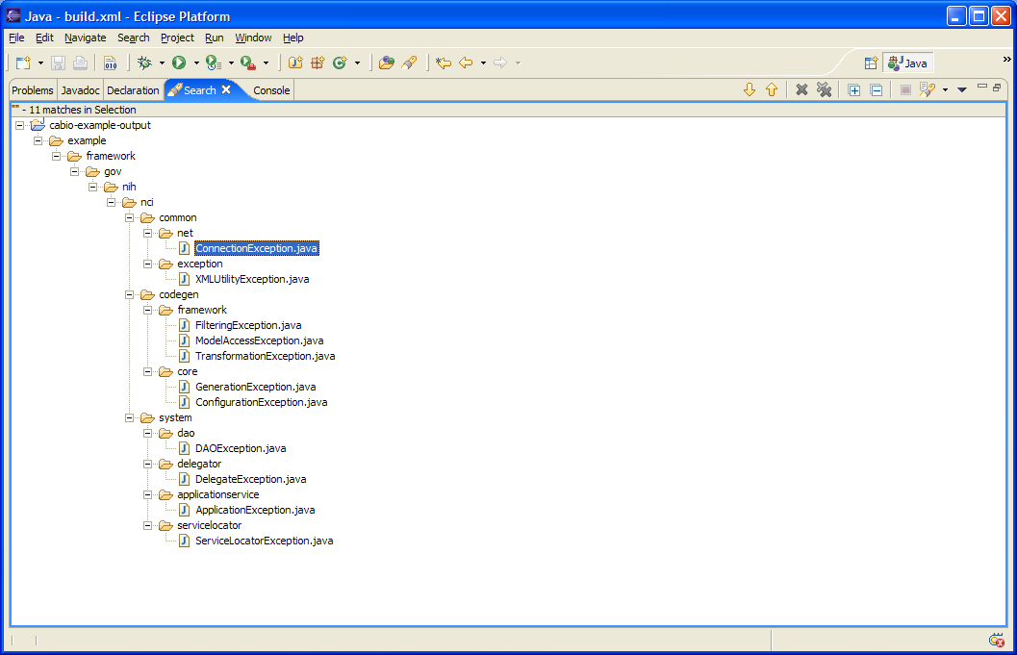
Relatively Well-Defined Set of Custom Exceptions Classes.
Scope of Exception Handling Focus within this Document
Analysis of Exception Handling Practices within the CABIO Sample System
Figure 1: Current Set of caCORE SDK Exception Classes

A closer inspection of the exception handling practices within the example generated system shows that, for the most part, exceptions are defined and used in a manner consistent with exception handling Best Practices: the exception name (type) communicates the kind of exception, the stack trace communicates the location to the SDK developer or programmer, and the exception message communicates additional information to the end user that might be helpful in determining and correcting the error.

As an example, let’s examine the usage of the DAOException class, shown below:

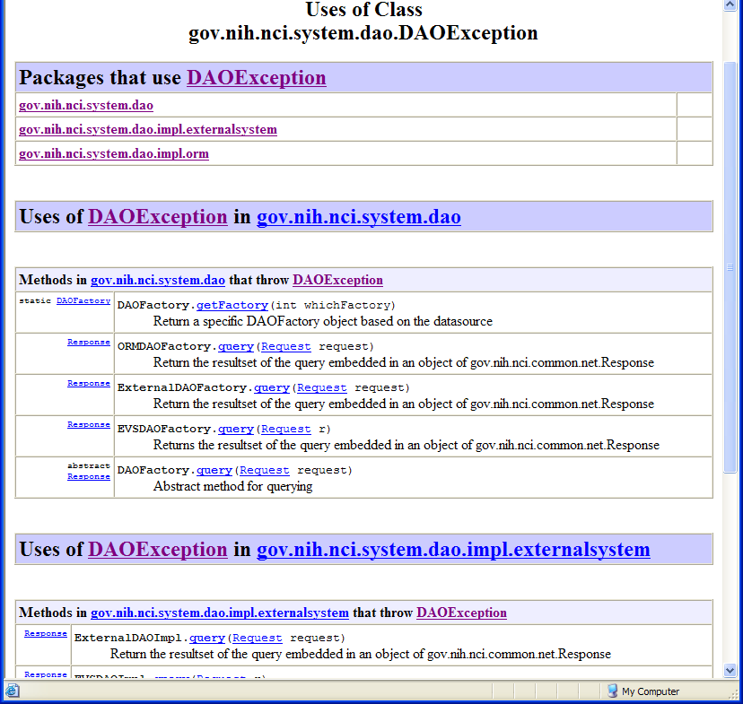
The DAOException is both Defined and Used within the dao Packages and their Classes
The Methods that Throw DAOException are related to Data Access Functions.
Figure 2: An Example: The Use of Class DAOException

The DAOException class is both defined and applied within the dao packages and their classes. The use of the DAOException is also consistent with its type and definition; i.e., the methods that throw DAOException, such as get[DAO]Factory and query, are related to data access functions. The developer, calling system, or end user that receives a DAOException thus has a good indication of the nature of the exception, its location, and the root cause of the problem.

However, as we will examine in the next section, this is not the case with the exception class, ApplicationException.

Problems with the ApplicationException Class

The ApplicationException seems to be defined and used in an effective manner. Its name also seems to accurately convey the exception type, and is also consistent with its placement within the applicationservice package, and association with the ApplicationService interface.

However, the ApplicationException class, when applied with the generated system, is used for handling a wide variety of exceptional conditions. Some of these conditions include: query/search, persistence, and security functions (see diagrams below).

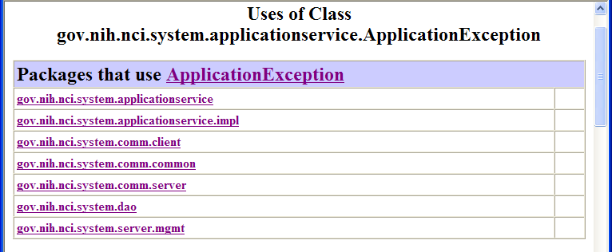
The ApplicationException is used generically within a Disparate Set of Packages and Classes that Implement Varying Query/Search, Persistence, and Security Functions.
Figure 3: Packages that Use ApplicationException

The listing and diagram below detail the variety of disparate classes, contained within the above package listing, that are associated with (i.e. that throw) ApplicationException:

- SecurityEnabler
- WriteableDAO
- Client Session
- ApplicationService
- ApplicationServiceClientImpl
- ApplicationServiceServerImpl

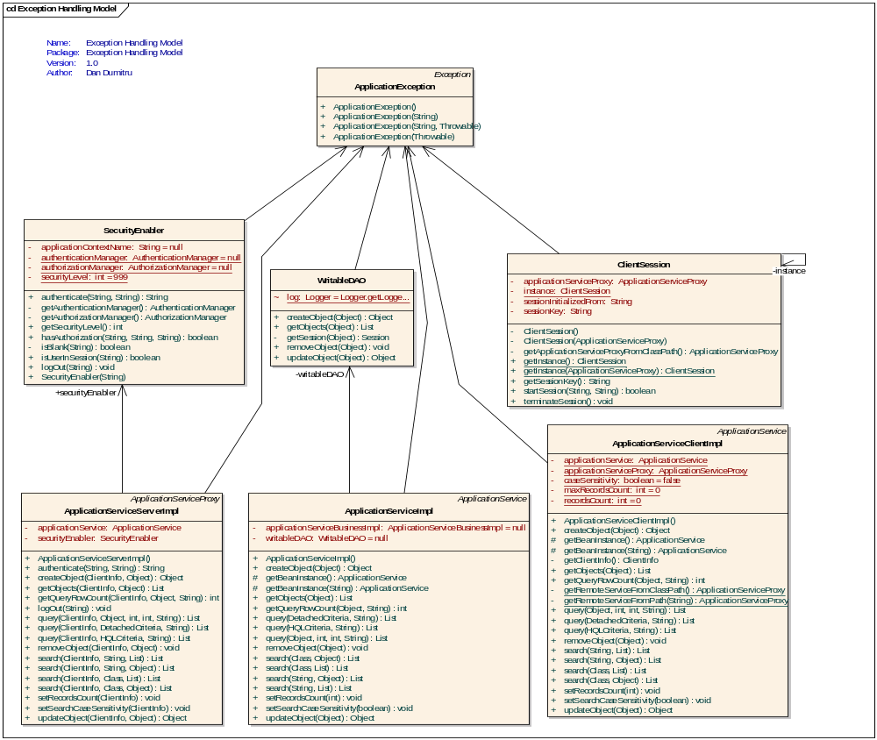
The ApplicationException is associated with (thrown from) a variety of classes, including:
- SecurityEnabler
- WriteableDAO
- ClientSession
- ApplicationService
- ApplicationServiceClientImpl
- ApplicationServiceServerImpl
Figure 4: Classes that Use (Throw) ApplicationException

Within this context, the ApplicationException name (type) becomes too general, and its usage too broad, to effectively communicate the root cause of the exceptional condition. End users are required to spend more time and effort than necessary interpreting and investigating the exception in order to determine the nature of the exception, its location, and the root cause of the problem.

Proposed Exception Handling Enhancements
This section describes the proposed exception handling enhancements that will clarify the cause of checked exceptions but still remain backwards compatible with the current release.

Introduction of More Specific Exception Classes
In order to enhance the exception handling of the caCORE SDK generated system in a manner that preserves backwards compatibility with the current release, it is proposed that a more specific exception class hierarchy be created, as shown below:
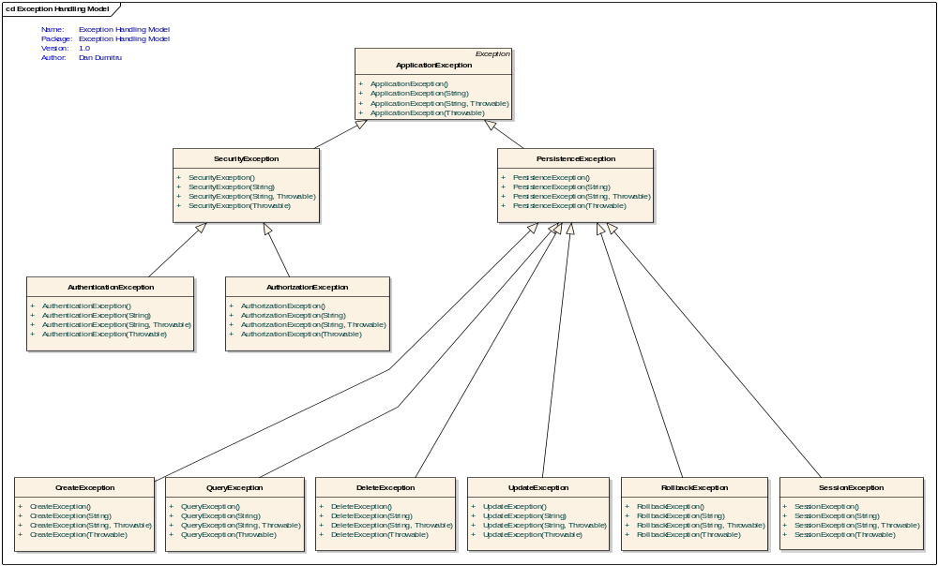
Figure 5: Proposed Exception Class Hierarchy
For improved readability, the same exception class hierarchy is provided below in list format:
- gov.nih.nci.system.applicationservice.ApplicationException
  - gov.nih.nci.system.applicationservice.SecurityException
    - gov.nih.nci.system.applicationservice.AuthenticationException
    - gov.nih.nci.system.applicationservice.AuthorizationException
  - gov.nih.nci.system.dao.DAOException
    - gov.nih.nci.system.dao.CreateException
    - gov.nih.nci.system.dao.QueryException
    - gov.nih.nci.system.dao.DeleteException
    - gov.nih.nci.system.dao.UpdateException
    - gov.nih.nci.system.dao.RollbackException
    - gov.nih.nci.system.dao.SessionException

Alternate or additional persistence related exception classes under consideration (inspired by the javax.PersistenceException API) include:
- gov.nih.nci.system.applicationservice.EntityExistsException
- gov.nih.nci.system.applicationservice.EntityNotFoundException
- gov.nih.nci.system.applicationservice.NonUniqueResultException
- gov.nih.nci.system.applicationservice.NoResultException
- gov.nih.nci.system.applicationservice.OptimisticLockException
- gov.nih.nci.system.applicationservice.TransactionRequiredException
Sub-classing the proposed exceptions from a common parent, ApplicationException, allows exception handling to proceed in a more object-oriented manner. Callers that invoke the ApplicationService interface(s) can choose to treat all Application Exceptions equally as they do now with a single catch block. However, if the callers desire to deal with one of the proposed exception classes in a specific manner, they can catch the more specific exception type first and recover appropriately.

Code Changes to Classes that Use (Throw) ApplicationException
Classes that currently use (throw) ApplicationException will be modified to now throw one of the three (3) more specific exception classes, QueryException, DAOException, or SecurityException, as illustrated below:

catch (Exception ex)
{
throw new ApplicationException("Could not obtain session for this entity! Could not create object");
}

Figure 6: Current Exception Handling Practice
catch (Exception ex)
{
throw (ApplicationException)(new SessionException("Could not obtain session for this entity! Could not create object", ex));
}

Figure 7: Proposed Exception Handling Practice
With this practice, none of the existing method signatures would change, thus preserving backwards compatibility with the current release.

Additionally, the proposed exception handling practice now also preserves the original exception via the constructor that takes a throwable cause as the second argument, thus providing more detailed information to the caller catching the thrown exception.

Query Detail Design
This section details the current SDK Query design, and, where applicable, describes opportunities to improve it. The information described herein is intended to complement the information contained within Chapter 3, Interacting with caCORE of the caCORE 3.1 Technical Guide. It is recommended that Chapter 3 be read before, or in conjunction with, this section in order to obtain the greatest clarity and comprehension.
Areas covered in this section include:
- The caCORE SDK tiered architecture, with the Query interface area highlighted
- Supported query types, including Simple, Nested, Detached Criteria, and HQL Search types
- Supported query interfaces, including the Java, XML-HTTP, and Web Service API’s
- How a Query is parsed and converted into one of the supported query types

The Query Interfaces within the caCORE SDK Tiered Architecture
Any system generated by the caCORE SDK shares the architecture shown below, which divides the generated application into a series of layers, or tiers:

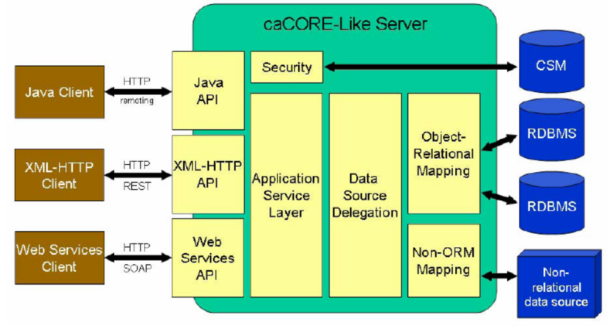
Query Interfaces within the caCORE SDK Architecture
Figure 8: Query Interfaces within the caCORE SDK Tiered Architecture
While various functional areas, or tiers, are shown in the diagram, attention is focused in this section primarily to the query interaction between the Client and Application Service tiers, as highlighted above.
The following sections discuss the various query types and interfaces, and details query processing sequences that take place within the Application Service layer prior to being handed off to the to the Persistence Tier for final processing.

Supported SDK Query Types
As described in the Technical Guide, the caCORE architecture includes an Application Service layer, or tier, that provides a single, common access paradigm to clients that rely heavily on strongly typed objects and an object-in/object-out mechanism. The methodology used for obtaining data from caCORE systems is often referred to as Query-by-Example. This methodology means that the inputs to the query methods are themselves domain objects that provide the criteria for the returned data.
The four (4) generalized types of queries, or searches, provided via the Application Service interface include:
- Simple Search: takes one or more domain objects as input, and returns a collection of objects from a persistent data source that meets the criteria specified by the input object.
- Nested Search: also takes one or more domain objects as input, but determines the type of objects in the result set by traversing a known path of associations from the domain model.
- Detached Criteria Search: takes a Hibernate Detached Criteria object as input, which is used to provide a greater level of control over the results of a search due to its ability to more readily specify Boolean operations, and range values.
- HQL Query Search: takes a Hibernate Query Language (HQL) string as input.
A sequence diagram illustrating the various possible query type interactions between a client and the SDK Application Service interface is shown below:
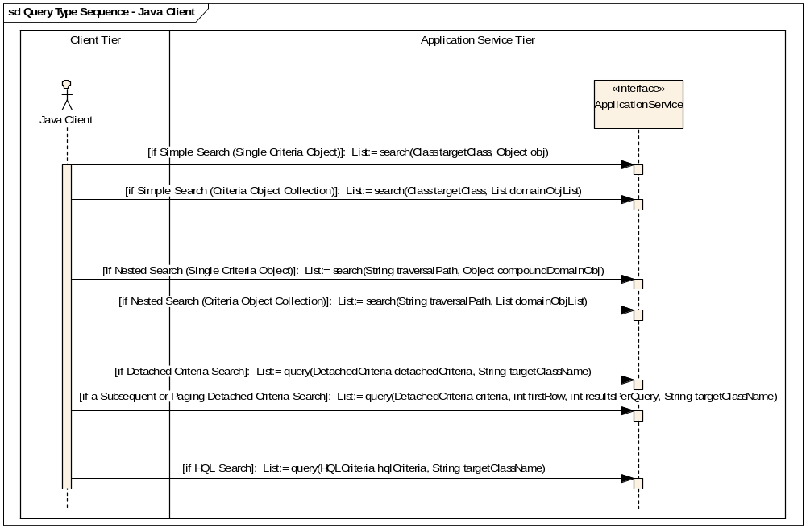
Figure 9: SDK Query Types
As illustrated in the diagram above, support for all four query types is implemented via a total of seven (7) application service methods. Each method is described briefly below.

Simple Search Query Type
The Simple Search query type is implemented via the following two Application Service interface query methods:
- Single Criteria Object [List:= search(Class targetClass, Object domainObj)]: Returns a List collection containing objects of the same type as the targetClass parameter that conform to the criteria defined by the domain object parameter, domainObj. Note that the single criteria object can be a compound (composite) object.
Example: search(Gene.class, gene).
- Criteria Object Collection [List:= search(Class targetClass, Object domainObjList)]: Returns a List collection containing objects of the same type as the targetClass parameter that conform to the criteria defined by a collection of objects in domainObjList. The returned objects must meet ANY criteria in domainObjList (i.e. a logical OR is performed).

Example: search(Gene.class, geneCollection).

Nested Search Query Type
The Nested Search query type is implemented via the following two Application Service interface query methods:

- Single Criteria Object [List:= search(String traversalPath, Object domainObj)]: Returns a List collection containing objects conforming to the criteria defined by domainObj and whose resulting objects are of the type reached by traversing the node graph specified by traversalPath.

Example: search("gov.nih.nci.cabio.domain.Protein, gov.nih.nci. cabio.domain.Gene", nucleicAcidSequence)
- Criteria Object Collection [List:= search(String traversalPath, List domainObjList)]: Returns a List collection containing objects conforming to the criteria defined by the objects in domainObjList and whose resulting objects are of the type reached by traversing the node graph specified by traversalPath.

Example: search("gov.nih.nci.cabio.domain.Protein, gov.nih.nci.cabio.domain.Gene", sequenceList)

Detached Criteria Query Type
The Detached Criteria Search query type is implemented via the following two Application Service interface query methods:

- Initial Search [List:= query(DetachedCriteria detachedCriteria, String targetClassName)]: Returns a List collection conforming to the criteria specified by Hibernate detachedCriteria and whose resulting objects are of the type specified by targetClassName.

Example: query(criteria, "gov.nih.nci.cabio.domain.Gene").

- Subsequent or Paging Search [List:= query(Object criteria, int firstRow, int resultsPerQuery, String targetClassName)]: Identical to the previous query method, but allows for greater control over the size of the returned result set by specifying the row number of the first row and the maximum number of objects to be returned.

Example: query(criteria, 101, 100, targetClassName).

HQL Criteria Query Type
The HQL Criteria Search query type is implemented via the following Application Service interface query method:

- HQL Search [List:= query(HQLCriteria hqlCriteria, String targetClassName)]: Returns a List collection of objects of the type specified by targetClassName that conform to the query in Hibernate Query Language (HQL) syntax contained in hqlCriteria.

Example: query(hqlCriteria, "gov.nih.nci.cabio.domain.Gene")

In an effort to minimize repetition, please refer to the Service Methods and Examples of Use sections of the caCORE 3.1 Technical Guide, pages 17-26 for a more detailed description of each of the service method signatures, as well as some example code.

Supported SDK Query Interfaces
As described in the Technical Guide, the caCORE architecture includes a service layer that provides a single, common access paradigm to clients via four (4) interfaces, including:
- Java API
- Web Services API
- XML-HTTP API

Each of the interfaces is discussed below.

Java API
As described in the caCORE 3.1 Technical Guide, the Java API provides direct access to domain objects and all application service methods for both local and remote Java clients. Because caCORE is natively built in Java, this API provides the fullest set of features and capabilities, and supports all four basic query types discussed in the section, Supported SDK Query Types.
A Sequence diagram illustrating the query interaction between a local Java client and the SDK native Java interface is shown below:
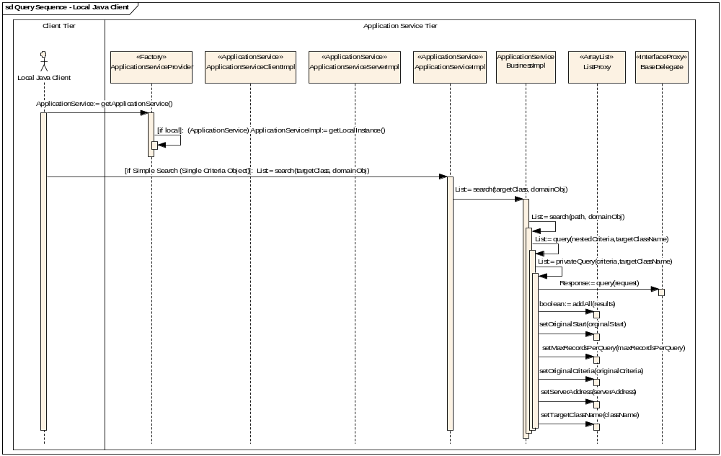
Figure 10: Query Sequence - Local Java Client
A Sequence diagram illustrating the query interaction between a remote Java client and the SDK native Java interface is shown below:
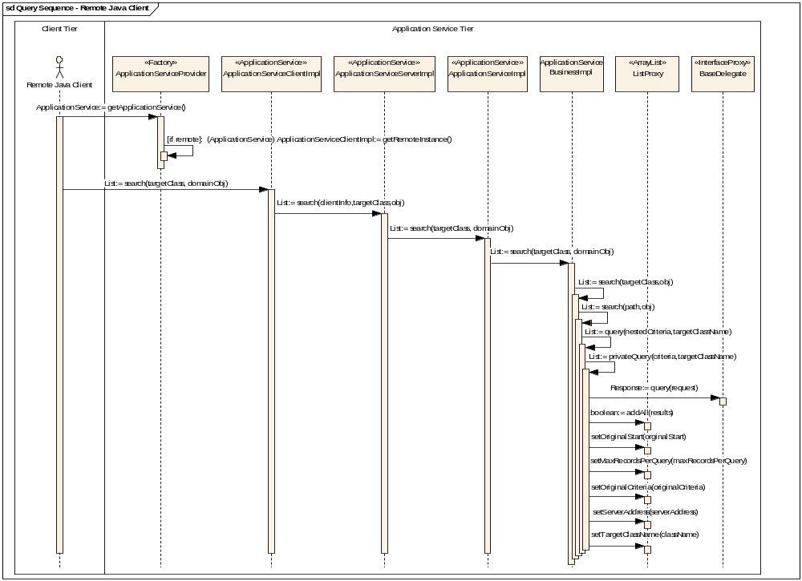
Figure 11: Query Sequence - Remote Java Client
The following sections detail the Java API SDK classes participating in the Sequence diagram shown above.

gov.nih.nci.system.applicationservice.ApplicationServiceProvider
The gov.nih.nci.system.applicationservice.ApplicationServiceProvider class implements a variation of the Creational Factory Pattern, which, given a super class and n sub-classes, and based on data provided, creates and returns the object of one of the sub-classes.

In the case of the SDK, the ApplicationServiceProvider creates an appropriate local or remote instance of the Application Service Interface super class, depending on whether the client that is invoking the ApplicationServiceProvider getRemote() method is local or remote, and returns it to the client.

An outline diagram listing the ApplicationServiceProvider attributes and methods is shown below:
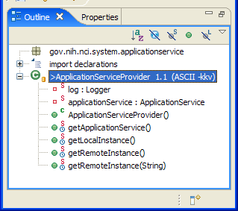
Figure 12: gov.nih.nci.system.applicationservice.ApplicationServiceProvider Outline Diagram

gov.nih.nci.system.comm.client.ApplicationServiceClientImpl
The gov.nih.nci.system.comm.client.ApplicationServiceClientImpl class provides the client-side, local implementation of the Application Service interface class, and is returned by the ApplicationServiceProvider Factory class in the case when the Java client is remote to the SDK server.

The ApplicationServiceClientImpl forwards all query/search calls to its server-side counterpart, ApplicationServiceServerImpl, which is discussed in the next section.

An outline diagram listing the ApplicationServiceClientImpl attributes and methods is shown below. Note the implementation of the seven (7) application service methods that support all four query types discussed in the section, Supported SDK Query Types:
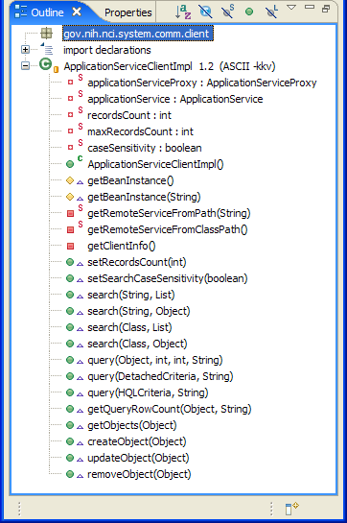
Figure 13: gov.nih.nci.system.comm.client.ApplicationServiceClientImpl Outline Diagram

gov.nih.nci.system.comm.server.ApplicationServiceServerImpl
The gov.nih.nci.system.comm.server.ApplicationServiceServerImpl class provides the server-side, remote implementation of the Application Service interface class, and is used in the case when the Java client is remote to the SDK server.

ApplicationServiceServerImpl forwards all query/search calls to ApplicationServiceImpl, which is discussed in the next section.

An outline diagram listing the ApplicationServiceServerImpl public methods is shown below. Note the implementation of the seven (7) application service methods that support all four query types discussed in the section, Supported SDK Query Types:
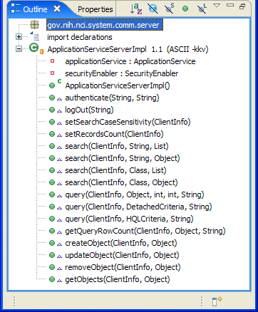
Figure 14: gov.nih.nci.system.comm.server.ApplicationServiceServerImpl Outline Diagram

gov.nih.nci.system.applicationservice.impl.ApplicationServiceImpl
The gov.nih.nci.system.applicationservice.impl.ApplicationServiceImpl class is a business service object that implements the business logic of the ApplicationService interface, which provides a variety of query/search methods for querying the SDK generated HTTP server.

Additionally, the ApplicationServiceImpl class implements the persistence Writeable DAO functionality, which is discussed in the section Writeable DAO: Create, Read, Update, Delete Interface.

The ApplicationServiceImpl forwards all query/search calls to ApplicationServiceBusinessImpl, which is discussed in the next section.

NOTE: The ApplicationServiceImpl and ApplicationServiceBusinessImpl provide redundant functionality, and should be combined into a single class.

An outline diagram listing the ApplicationServiceBusinessImpl attributes and methods is shown below. Note the implementation of the seven (7) application service methods that support all four query types discussed in the section, Supported SDK Query Types:
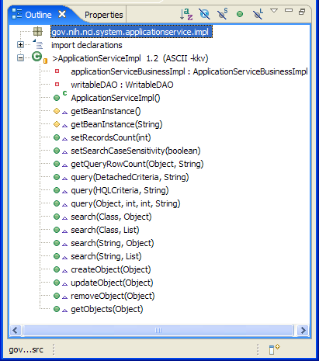
Figure 15: gov.nih.nci.system.applicationservice.impl.ApplicationServiceImpl Outline Diagram

gov.nih.nci.system.applicationservice.impl.ApplicationServiceBusinessImpl
The gov.nih.nci.system.applicationservice.impl.ApplicationServiceBusinessImpl class is a business service object that implements the business logic of the ApplicationService interface, which provides a variety of query/search methods for querying the SDK generated HTTP server.
NOTE: The ApplicationServiceImpl and ApplicationServiceBusinessImpl provide redundant functionality, and should be combined into a single class.

An outline diagram listing the ApplicationServiceBusinessImpl attributes and methods is shown below. Note the implementation of the seven (7) application service methods that support all four query types discussed in the section, Supported SDK Query Types:
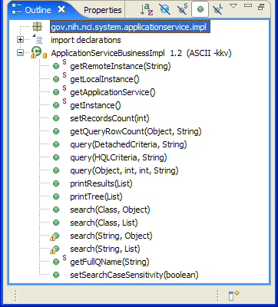
Figure 16: gov.nih.nci.system.applicationservice.impl.ApplicationServiceBusinessImpl Diagram

gov.nih.nci.common.util.ListProxy
The gov.nih.nci.common.util.ListProxy class implements the List interface, extending the ArrayList class. It is used to hold the results of a given query, along with details of the original request, including the original query criteria object, start index, serverAddress, targetClassName, and the real size of result list, if completely materialized.

An outline diagram listing the ListProxy attributes and methods is shown below.
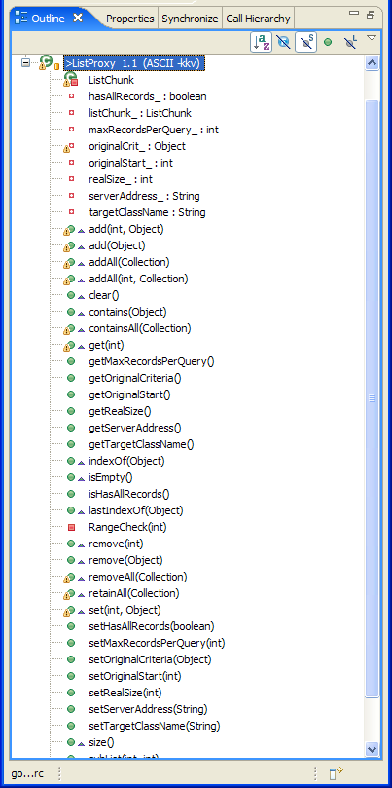
Figure 17: gov.nih.nci.common.util.ListProxy Outline Diagram

Web Services API
As described in the caCORE 3.1 Technical Guide, the caCORE Web services API allows access to caCORE data from development environments where the Java APIs cannot be used, or where use of XML Web services is more desirable. This includes non-Java platforms and languages such as Perl, C/ C++, .NET Framework (C#, VB.Net), Python, etc. The Web services interface can be used in any language-specific application that provides a mechanism for consuming XML Web services based on the Simple Object Access Protocol (SOAP). In these environments, connecting to caCORE can be as simple as providing the endpoint URL. Some platforms and languages require additional client-side code to handle the implementation of the SOAP envelope and the resolution of SOAP types. A list of packages catering to different programming languages is available at http://www.w3.org/TR/SOAP/ and at http://www.soapware.org/.
To maximize standards-based interoperability, the caCORE Web service conforms to the Web Services Interoperability Organization (WS-I) Basic Profile.
The Web Services API provides a limited subset of the query features and capabilities of the SDK, and only supports one (Simple Search) of the four basic query types discussed in the section, Supported SDK Query Types.
A Sequence diagram illustrating the query interaction between a Web Service client and the SDK Web Service interface is shown below:
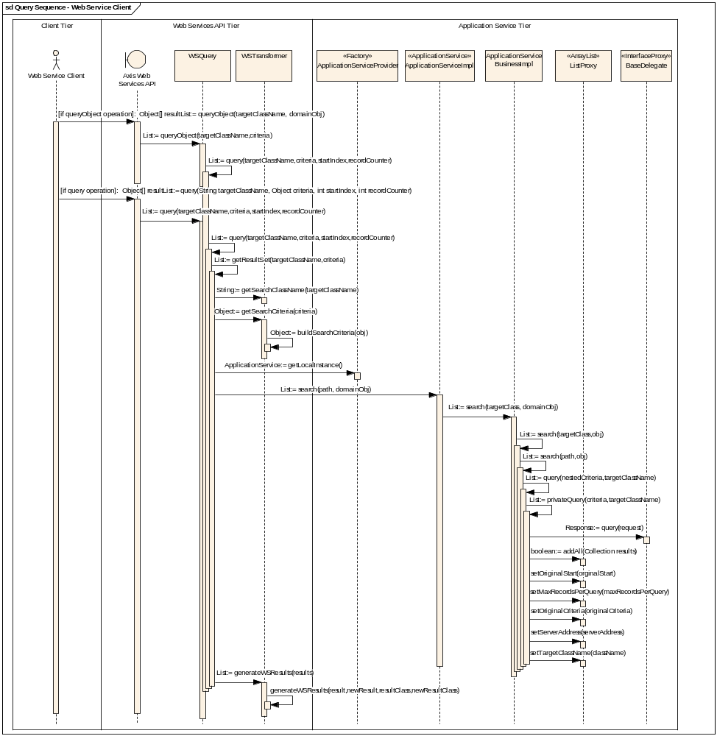c
Figure 18: Query Sequence - Web Service Client
The following sections detail the Web Services API SDK classes participating in the Sequence diagram shown above.

Web Services Client
The Web Services Client actor represents a client written in any of the languages, such as Perl, C/ C++, .NET Framework (C#, VB.Net), or Python, that support XML Web Services based on the Simple Object Access Protocol (SOAP).

Axis Web Services API
On the SDK server side of the Web Services API, Apache Axis is used to provide SOAP-based inter-application communication. Axis provides the appropriate serialization and de-serialization methods for the Java beans to achieve an application-independent interface.

gov.nih.nci.system.webservice.WSQuery
The gov.nih.nci.system.webservice.WSQuery is the backend implementation class for the Axis Web Services API, and implements the queryObject and query operations.
The queryObject operation performs a search for objects conforming to the criteria defined by the criteria domain object input parameter. The resulting objects can be reached by traversing the node graph specified by the parameter that indicates the target class name path. The result is a set of serialized objects.
The query operation is almost identical to the queryObject operation. The query operation allows for control over the result by specifying the row number of the first row via the startIndex parameter, and setting the maximum number of objects to return via the recordCounter parameter.
As mentioned before, the Web Services API provides a limited subset of the query features and capabilities of the SDK, and only supports one (Single Criteria Object, Simple Search) of the four basic query types discussed in the section, Supported SDK Query Types. More specifically, the queryObject and query operations provide a Web Service interface to the Single Criteria Object Simple Search query type discussed in the section, Simple Search Query Type.
An example of an Axis client Web Service invocation is shown below:
Object[] resultList = (Object[])call.invoke(
new Object[]{"gov.nih.nci.cabio.domain.ws.Gene", gene });
An outline diagram listing the WSQuery attributes and methods is shown below:
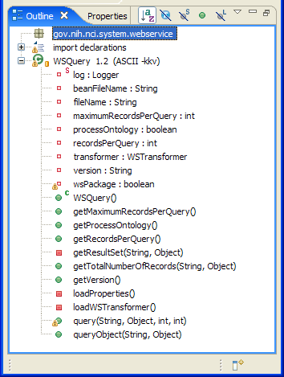
Figure 19: gov.nih.nci.system.webservice.WSQuery Outline Diagram
Please refer to the Operations, Web Services API section of the caCORE 3.1 Technical Guide documentation for more information and examples.

gov.nih.nci.system.webservice.WSTransformer
The gov.nih.nci.system.webservice.WSTransformer is a Helper class used by the WSQuery class to transform (deserialize) a query request (via the buildSearchCriteria(), getSearchClassName(), and getSearchCriteria() methods) into a format understood by the Application Service interface.
The WSTransformer class also provides a method, generateWSResults(), which serializes query results into a format suitable for transport and return to the Web Service Client.
An outline diagram listing the WSTransformer attributes and methods is shown below:
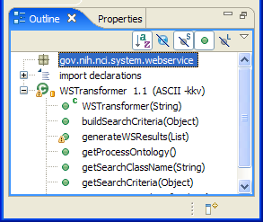
Figure 20: gov.nih.nci.system.webservice.WSTransformer Outline Diagram

XML-HTTP API
As described in the caCORE 3.1 Technical Guide, the caCORE XML-HTTP API, based on the Representational State Transfer (REST) architectural style, provides a simple interface using the HTTP protocol. In addition to its ability to be invoked from most internet browsers, developers can use this interface to build applications that do not require any programming overhead other than an HTTP client. This is particularly useful for developing web applications using AJAX (asynchronous JavaScript and XML).
A Sequence diagram illustrating the query interaction between an XML or HTTP client and the SDK XML-HTTP API is shown below:
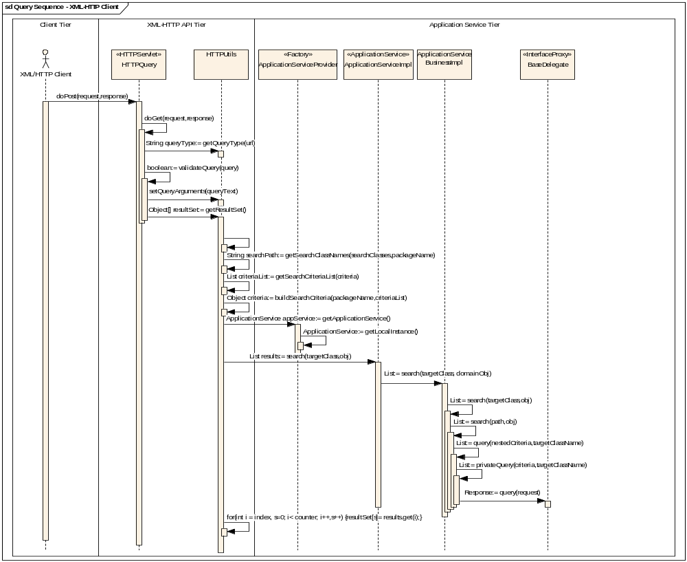
Figure 21: Query Sequence – XML-HTTP Client
The following sections detail the XML-HTTP API SDK classes participating in the Sequence diagram shown above.

gov.nih.nci.system.proxy.HTTPQuery
The gov.nih.nci.system.proxy.HTTPQuery extends the standard javax.servlet.http.HttpServlet class. One of its primary functions is to interpret the query request embedded within a standard HttpRequest object, and to make the appropriate calls to the caCORE Server. The results are sent back to the user as an XML or HTML document depending upon whether the GetXML or GetHTML Servlet request was made.
XQuery-like syntax is used to generate the query. The syntax of the query is shown below:
http://{server}/{servlet}?query={returnClass}&{criteria}&
resultCounter={counter}&startIndex={index}&
pageSize={pageSize}&pageNumber={pageNumber}
An example of the query is shown below:
http://server/servlet/GetXML?query=Gene&Gene[@symbol=brca*]
The value of {servlet} must be either GetXML, or GetHTML, as specified below in the highlighted portion of the web.xml file. Note that both the GetXML and GetHTML queries map to the same SDK HTTPQuery Servlet:
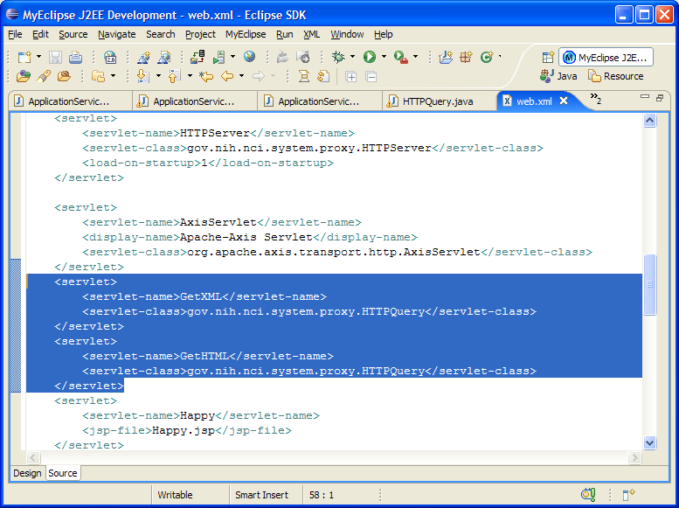
Figure 22: XML-HTTP Servlet Mappings
An outline diagram listing the HttpQuery attributes and methods is shown below:

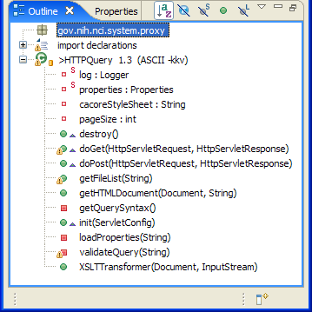
Figure 23: gov.nih.nci.system.proxy.HTTPQuery Outline Diagram
NOTE: The HTTPQuery class invokes methods on the SDK HTTPUtils class that caches and returns cached query result sets,for improved performance. This has the undesired side-effect of always returning the same result for subsequent queries even if the persistent data source has been modified (data has been added, updated, or deleted) via the Writable SDK interface, or externally, via some other means (such as Toad, a database management tool for Oracle). The code in question can be found in the HTTPQuery’s doGet() method, and should be removed to prevent user confusion and frustration:

if(!session.isNew() && prop != null){
match = httpUtils.getMatch(prop);
}

try{
if(match){
List results = (List)prop.getResults();
httpUtils.setResults(results);
resultSet = httpUtils.getCachedResultSet();

}
else{
resultSet = httpUtils.getResultSet();
}
} catch(){}

Please refer to the Service Location and Syntax, XML-HTTP API section of the caCORE 3.1 Technical Guide documentation for more information on the XML-HTTP query syntax, as well as usage examples.

gov.nih.nci.common.util.HTTPUtils
As its name implies, the HTTPUtils is a utility, or helper class used by the HTTPQuery class discussed in the previous section. The HTTPUtils class provides various methods to generate search criteria from XQuery like syntax, and also class also provides functionality to generate XML results.
NOTE: The HTTPUtils class also provides methods to cache and return cached query result sets, presumably for performance reasons. This has the undesired side-effect of always returning the same result for subsequent queries even if the persistent data source has been modified (data has been added, updated, or deleted) via the Writable SDK interface, or externally, via some other means (such as Toad, a database management tool for Oracle).

It is recommended that these caching methods be removed, as their use can and has caused confusion with users of the XML/HTTP interface. The methods in question include:
- getCachedResultSet();
- getMatch(HTTPUtils);
- setResults();

An outline diagram listing the HttpQuery public methods is shown below:
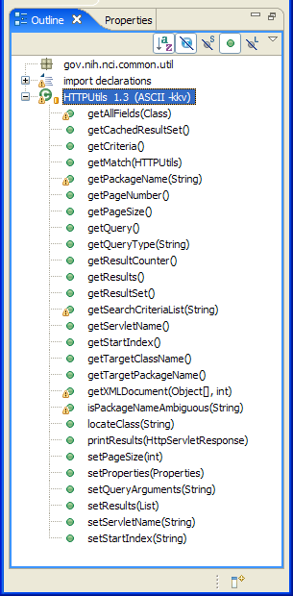
Figure 24: gov.nih.nci.common.util.HTTPUtils Outline Diagram

Persistence Tier Detail Design
This section details the current SDK persistence design, and describes opportunities to improve it. Areas covered in this section include:
- The Persistence Tier within the caCORE SDK Tiered Architecture
- The Base Delegate Query Interface
- The Writable DAO Create, Read, Update, Delete (CRUD) Interface

The Persistence Tier within the caCORE SDK Tiered Architecture
Any system generated by the caCORE SDK is divided into a series of layers, or tiers (see Figure 25 below).

Persistence Tier within the caCORE SDK Architecture

Figure 25: Persistence Tier within the caCORE SDK Tiered Architecture
While various functional areas are shown in the diagram, the focus of this section is to what has been termed the “Persistence Tier.” The “Persistence Tier” includes: the Data Source delegation, Object-Relational Mapping (ORM), and the non-ORM mapping functional areas highlighted above.
Interaction between the Application Service and the Persistence Tiers currently occurs via one of the two following “interfaces”:
- Base Delegate Query Interface
- Writable DAO Create, Read, Update, Delete (CRUD) Interface
Each interface is discussed below.

NOTE: Consideration is being given to combining both persistence tier interfaces, as there is currently an overlap in functionality; i.e., both interfaces provide read, or query, capabilities. Logically, it makes sense to have a single persistence tier Create, Read, Update, Delete (CRUD) interface, perhaps implemented via a variation of the Session Façade and/or Business Delegate pattern(s).

Base Delegate Query Interface
The following sequence diagram illustrates the interaction between the Application Service and Object-Relational Mapping (ORM) Persistence tier classes (including several Hibernate ORM classes), as implemented via the Base Delegate Query interface:
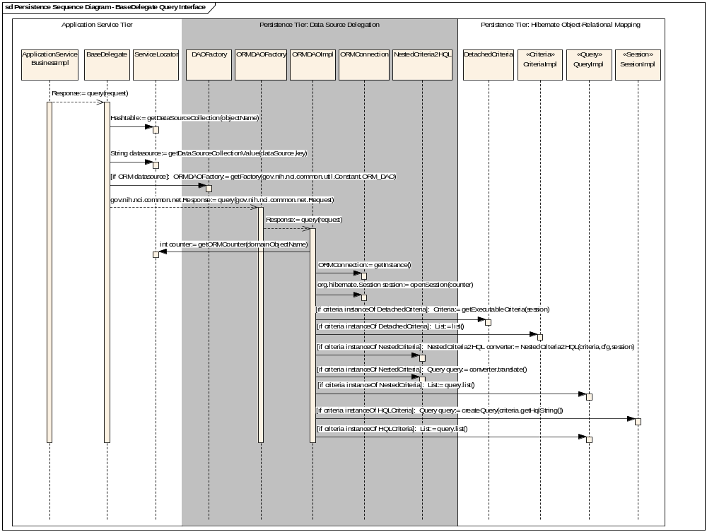
The SDK makes provision for up to two (2) RDBMS data sources.
The public getORMCounter(String domainObjectName) method determines which of the two RDBMS data sources a particular domain object is mapped to.
See the ServiceLocator section for more details.
Figure 26: Persistence Tier (Base Delegate Query Interface) Sequence Diagram
The Sequence diagram above provides a structured representation of the SDK persistence behavior as a series of sequential steps over time as implemented via the Base Delegate Query interface. The diagram also illustrates the message passing between various participating SDK classes, and how these classes cooperate over time to process a gov.nih.nci.common.net.Request object to produce a query result returned in the form of a gov.nih.nci.common.net.Response object.

Presentation Tier clients, as well as RDBMS data sources, are omitted from the diagram in order to preserve focus, and also due to space limitations.

The following sections detail the SDK classes participating in the Sequence diagram shown above.

gov.nih.nci.system.applicationservice.impl.ApplicationServiceBusinessImpl
The gov.nih.nci.system.applicationservice.impl.ApplicationServiceBusinessImpl class is a business service object that implements the ApplicationService interface, which provides a variety of methods for querying the HTTP server.

An outline diagram listing the ApplicationServiceBusinessImpl attributes and methods is shown below:
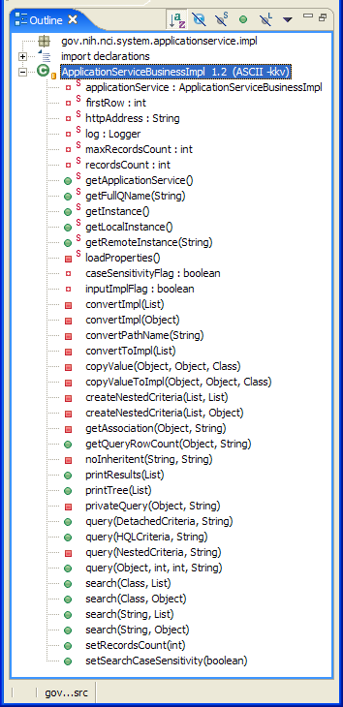
Figure 27: gov.nih.nci.system.ApplicationBusinessImpl Outline Diagram

gov.nih.nci.common.net.Request
The gov.nih.nci.common.net.Request class (not shown in the sequence diagram due to space limitations) implements a variation of the Data Transfer Object pattern, which is used to encapsulate and transfer business data across application tiers.

The Request class encapsulates a client’s query request details, including configuration data to connect to a specified data source, the name (type) of the domain object being queried, and the selection criteria.

An outline diagram listing the Request attributes and methods is shown below:
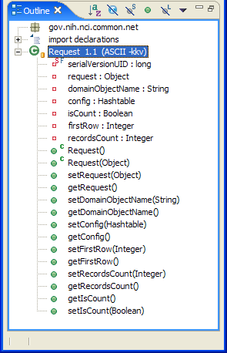
Figure 28: gov.nih.nci.common.net.Request Outline Diagram

gov.nih.nci.common.net.Response
The gov.nih.nci.common.net.Response class (not shown in the sequence diagram due to space limitations) implements a variation of the Data Transfer Object pattern, which is used to encapsulate and transfer business data across application tiers.

The Response object encapsulates the result of a client’s query request, including a List of objects (stored in the response attribute) that met the query criteria. The type and number of objects returned in the list is determined, in part, by the name of the domain object stored in the Request domainObjectName attribute and the filtering criteria stored in the Request request attribute.

An outline diagram listing the Response attributes and methods is shown below:
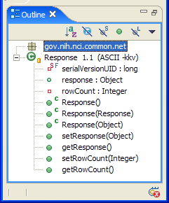
Figure 29: gov.nih.nci.common.net.Response Outline Diagram

gov.nih.nci.system.delegator.BaseDelegate
The gov.nih.nci.system.delegator.BaseDelegate class implements a variation of the Business Delegate pattern. This pattern strives to reduce coupling between presentation-tier clients and business services.

In the case of the caCORE SDK, the BaseDelegate class hides the underlying implementation details of the query business service (such as the lookup and access details of the data access object architecture implemented within the persistence tier) from its internal client, the ApplicationService (ApplicationServiceBusinessImpl) class.

An outline diagram listing the BaseDelegate attributes and methods is shown below:
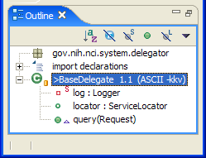
Figure 30: gov.nih.nci.system.delegator.BaseDelegate Outline Diagram

gov.nih.nci.system.servicelocator.ServiceLocator
The gov.nih.nci.system.servicelocator.ServiceLocator class implements a variation of the Service Locator pattern. This pattern reduces coupling between presentation-tier clients and business services.

In the case of the caCORE SDK, the ServiceLocator class hides the implementation details of the Data Access Object (DAO) lookup and access within the SDK persistence tier.

NOTE: The SDK makes provisions for up to two (2) RDBMS data sources. The public ServiceLocator getORMCounter(String domainObjectName) method determines which of the two RDBMS data sources a particular domain object is mapped to. The value returned by this method is typically passed to the ORMConnection openSession(counter) method, which uses the value to obtain a Hibernate Session to the appropriate data source. The two-step process, repeated in the ORMDAOImpl and WritableDAO classes, is shown in the code fragment below:
int oRMCounter = serviceLocator.getORMCounter(domainObjectName);
Session session = oRMConnection.openSession(oRMCounter);
This practice unnecessarily exposes clients to data source connection implementation details that are better encapsulated within the ORMConnection class. The suggested solution is to modify the ORMConnection openSession() method as follows:
Session session = oRMConnection.openSession(domainObjectName);
The ORMConnection class can use the domainObjectName value to determine the correct Session instance to return. In this manner, the client is spared from having to know how many data sources have been implemented.

An outline diagram listing the ServiceLocator attributes and methods is shown below:
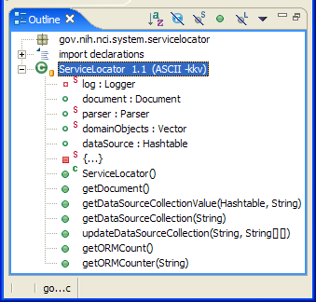
Figure 31: gov.nih.nci.system.servicelocator.ServiceLocator Outline Diagram

gov.nih.nci.system.dao.DAOFactory
The gov.nih.nci.system.dao.DAOFactory class implements the Factory for Data Access Objects strategy (see also the Factory Method [GoF] pattern), which deals with the problem of creating objects (products) without specifying the exact class of object that will be created. Factory Method, one of the patterns from the Design Patterns book, handles this problem by defining a separate method for creating the objects, which subclasses can then override to specify the derived type of product that will be created.

In the case of the caCORE SDK, the DAOFactory abstract class specifies the signature of the getFactory(int whichFactory) method common to all caCORE concrete DAO Factory subclasses, including the Object Relational Mapping Data Access Object Factory (ORMDAOFactory) class discussed in the following section.

NOTE: The abstract query(Request) method is a function that should be implemented by (is the responsibility of) an actual DAO implementation, and not the factory itself. As such, the query(Request) method would be better situated within a DAO class, such as ORMDAOImpl, and not defined within the abstract DAO Factory as shown below.

An outline diagram listing the DAOFactory attributes and methods is shown below:
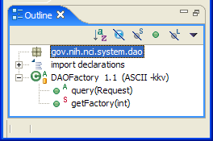
Figure 32: gov.nih.nci.common.net.Request Outline Diagram

gov.nih.nci.system.dao.ORMDAOFactory
The gov.nih.nci.system.dao.ORMDAOFactory object is a concrete subclass of the abstract DAOFactory class discussed in the previous section. It is responsible for creating Object Relational Mapping (ORM) DAO instances. It also implements the query(Request) method specified in the parent DAOFactory class.
NOTE: Again, as mentioned in the previous section, the query(Request) method is a function that should be fulfilled by (is the responsibility of) an actual DAO implementation, and not the factory itself. As such, the query(Request) method would be better situated within the DAO class, such as ORMDAOImpl. It should not be defined within the abstract DAO Factory as shown.

An outline diagram listing the ORMDAOFactory attributes and methods is shown below:
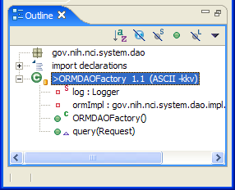
Figure 33: gov.nih.nci.system.dao.ORMDAOFactory Outline Diagram

gov.nih.nci.system.dao.impl.orm.ORMDAOImpl
The gov.nih.nci.system.dao.impl.orm.ORMDAOImpl class implements the Data Access Object (DAO) pattern. This pattern abstracts and encapsulates all access to a given data source. The DAO also manages the connection with the data source to obtain and store data.

ORMDAOImpl also implements the query(Request) method. This method converts a caCORE gov.nih.nci.common.net.Request into a corresponding Hibernate query that returns results from a specified ORM data source.

An outline diagram listing the ORMDAOImpl attributes and methods is shown below:
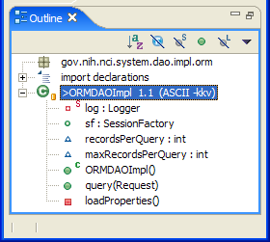
Figure 34: gov.nih.nci.system.dao.ORMDAOImpl Outline Diagram

gov.nih.nci.system.dao.impl.orm.ORMConnection
The gov.nih.nci.system.dao.impl.orm.ORMConnection is a Singleton object that creates and manages up to two instances of the Hibernate SessionFactory object. This Hibernate object is responsible for creating Hibernate Sessions. Threads servicing client requests obtain Sessions from the factory.

NOTE: As mentioned in the Hibernate SessionFactory API, an application usually has a single SessionFactory object. The caCORE SDK application, however, makes provisions for up to two SessionFactories, corresponding to the support for two simultaneous RDBMS data sources shown earlier in Figure caCORE SDK Tiered Architecture. The SessionFactory instances are stored in the sessionFactories attribute shown in the outline diagram below.

An outline diagram listing the gov.nih.nci.system.dao.impl.orm.ORMConnection attributes and methods is shown below:
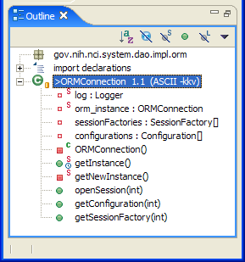
Figure 35: gov.nih.nci.system.dao.ORMConnection Outline Diagram

gov.nih.nci.common.util.NestedCriteria2HQL
The gov.nih.nci.common.util.NestedCriteria2HQL class primarily converts, or translates, a gov.nih.nci.common.util.NestedCriteria into a Hibernate HQL org.hibernate.Query, which is an object-oriented representation of a Hibernate query obtained by calling Session.createQuery().

An outline diagram listing the NestedCriteria2HQL attributes and methods is shown below:
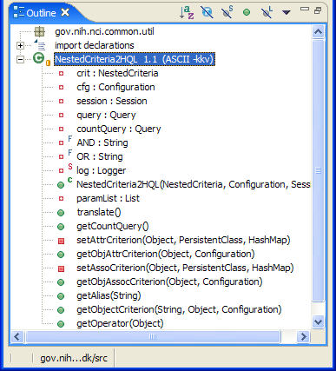
Figure 36: gov.nih.nci.system.dao.ORMConnection Outline Diagram

Writable DAO Create, Read, Update, Delete Interface
The following sequence diagram illustrates the interaction between the Application Service and Object-Relational Mapping (ORM) Persistence tier classes (including several Hibernate ORM classes), as implemented via the Writable DAO interface.

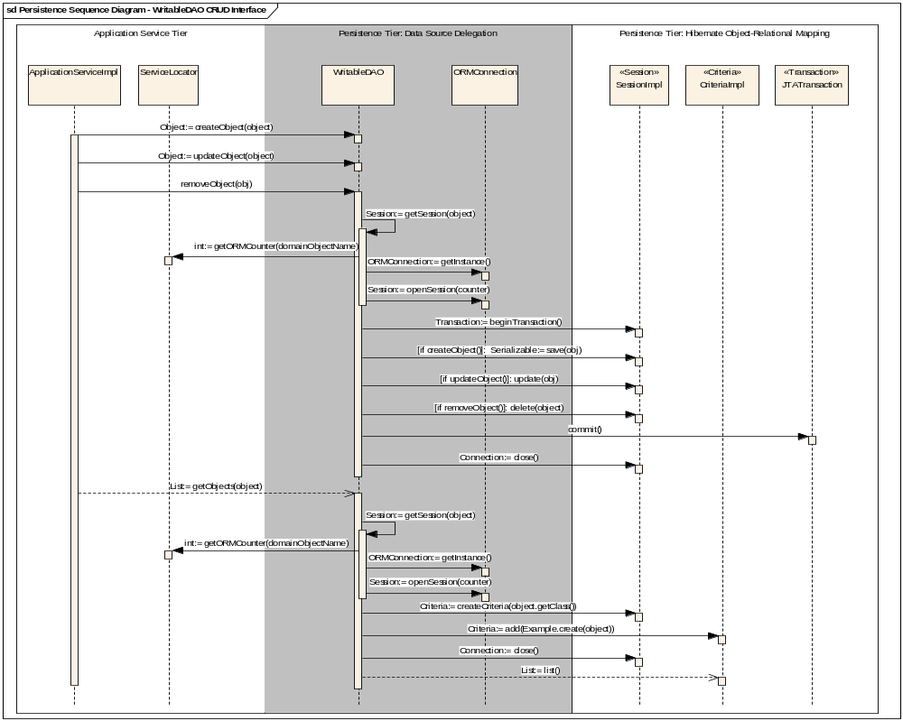
Figure 37: Persistence Tier (Base Delegate Query Interface) Sequence Diagram
The Sequence diagram above provides a structured representation of the SDK persistence behavior. It is displayed as a series of sequential steps over time, as implemented via the Writable DAO CRUD interface. The createObject(), updateObject(), and removeObject() all share the same basic set of sequential steps, with the exception of the Hibernate Session save(), update(), and delete() method invocations. The WritableDAO getObjects() method has a slightly different sequence of steps, and is shown separately at the bottom of the diagram.

The diagram also illustrates the message passing between various participating SDK classes, and how these classes cooperate over time to process a gov.nih.nci.common.net.Request object to produce a query result returned in the form of a gov.nih.nci.common.net.Response object.

Presentation Tier clients, as well as RDBMS data sources, are omitted from the diagram in order to preserve focus.

The following sections detail the SDK classes participating in the Sequence diagram shown above.

gov.nih.nci.system.applicationservice.impl.ApplicationServiceImpl
The gov.nih.nci.system.applicationservice.impl.ApplicationServiceImpl class implements the local (server side) instance of the ApplicationService interface (in contrast to the gov.nih.nci.system.comm.client.ApplicationServiceClientImpl class, which implements the remote (client side) instance).

The ApplicationServiceImpl class also acts as a wrapper class, forwarding the responsibility for handling requests to the ApplicationServiceBusinessImpl class; i.e., it just calls methods from the ApplicationServiceBusinessImpl class without doing any work itself.

A class diagram illustrating the relationships between the various ApplicationService interface related classes is shown below
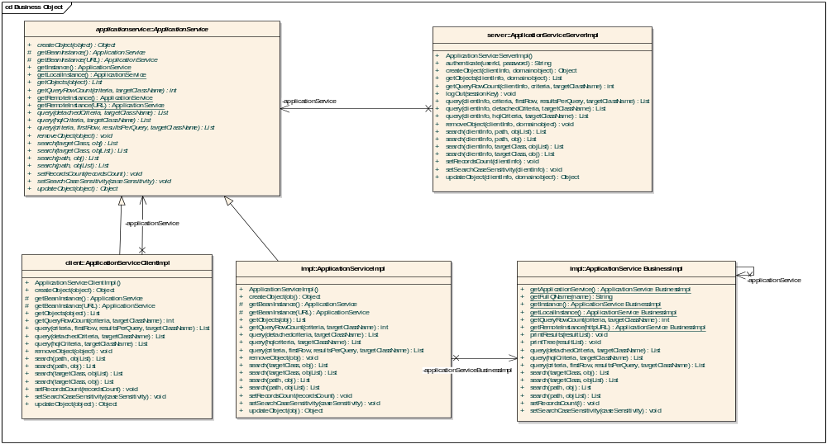
Figure 38: ApplicationService Interface and Related Classes Diagram
NOTE: As illustrated in the above diagram, this is one area of the SDK that is a prime candidate for being refactored and/or redesigned, as there seems to be a duplication of functionality and unnecessarily complex relationships.

An outline diagram listing the ApplicationServiceImpl attributes and methods is shown below:
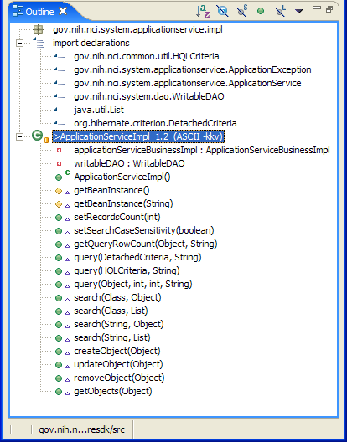
Figure 39: gov.nih.nci.system.dao.ORMConnection Outline Diagram

gov.nih.nci.system.dao.WritableDAO
The gov.nih.nci.system.dao.WritableDAO class implements the Data Access Object (DAO) pattern, which abstracts and encapsulates all access to a given data source. The DAO also manages the connection with the data source to obtain and store data.

The WritableDAO implements Create, Read, Update, and Delete (CRUD) functionality for those domain objects managed via the Hibernate object/relational persistence and query service.

NOTE: As mentioned previously, consideration is being given to combining both the BaseDelegate and WritableDAO persistence tier interfaces, as there is currently an overlap in functionality; i.e., both interfaces provide read, or query, capabilities. Logically, it makes sense to have a single persistence tier Create, Read, Update, Delete (CRUD) interface, perhaps implemented via a variation of the Session Façade and/or Business Delegate pattern(s).

An outline diagram listing the WritableDAO attributes and methods is shown below:

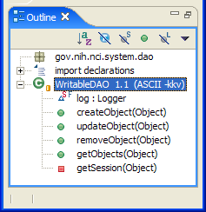
Figure 40: gov.nih.nci.system.dao.WritableDAO Outline Diagram

gov.nih.nci.system.servicelocator.ServiceLocator
Briefly, the gov.nih.nci.system.servicelocator.ServiceLocator class implements a variation of the Service Locator pattern, which reduces coupling between presentation-tier clients and business services.

The ServiceLocator class was already discussed in the earlier ServiceLocation section; please refer to this section for more information.

gov.nih.nci.system.dao.impl.orm.ORMConnection
The gov.nih.nci.system.dao.impl.orm.ORMConnection is a Singleton object that creates and manages up to two instances of the Hibernate SessionFactory object, which, in turn, is responsible for creating Hibernate Sessions. Threads servicing client requests obtain Sessions from the factory.

The ORMConnection class was already discussed in the earlier ORMConnection section; please refer to this section for more information.

Configuration/Deployment Considerations

Property/Configuration Files

New (*) or Modified (#) | File Location | File Name | Description of Change
# | gov.nih.nci.system.dao | WriteableDAO.java | Modify class to throw PesistenceException cast as an ApplicationException.
# | gov.nih.nci.system.comm.server | ApplicationServiceServerImpl | Modify class to throw sub classed exceptions of ApplicationException.
# | gov.nih.nci.system.comm.client | ApplicationServiceClientImpl | Modify class to throw sub classed exceptions of ApplicationException.
# | gov.nih.nci.system.comm.client | ClientSession | Modify class to throw sub classed exceptions of ApplicationException.
# | gov.nih.nci.system.applicationservice.impl | ApplicationServiceImpl | Modify class to throw sub classed exceptions of ApplicationException.
# | gov.nih.nci.system.server.mgmt | SecurityEnabler | Modify class to throw sub classed exceptions of ApplicationException.
* | gov.nih.nci.system.applicationservice | SecurityException | New Subclass of ApplicationException
* | gov.nih.nci.system.applicationservice | AuthenticationException | New Subclass of SecurityException
* | gov.nih.nci.system.applicationservice | AuthorizationException | New Subclass of SecurityException
* | gov.nih.nci.system.applicationservice | DAOException | Modified Subclass of ApplicationException
* | gov.nih.nci.system.applicationservice | CreateException | New Subclass of DAOException
* | gov.nih.nci.system.applicationservice | QueryException | New Subclass of DAOException
* | gov.nih.nci.system.applicationservice | UpdateException | New Subclass of DAOException
* | gov.nih.nci.system.applicationservice | DeleteException | New Subclass of DAOException
* | gov.nih.nci.system.applicationservice | SessionException | New Subclass of DAOException
* | gov.nih.nci.system.applicationservice | RollbackException | New Subclass of DAOException

Deployment Considerations
N/A.

Resources
This section contains a list of recommended reading materials, resources, and references that can be useful for becoming familiar with the concepts contained within this guide.

Technical Manuals/Articles
- Exceptional Practices: http://java.sun.com/developer/technicalArticles/Programming/exceptions/.
- Exceptional Practices, Part 2: http://java.sun.com/developer/technicalArticles/Programming/exceptions2/.
- javax.persistence class hierarchy: http://java.sun.com/javaee/5/docs/api/javax/persistence/package-tree.html.
- See also the java.lang.Throwable API regarding the Exception Chaining facility.

Core J2EE Patterns
- Core J2EE Patterns: Best Practices and Design Strategies, Deepak Alur, John Crupi and Dan Malks. Publisher: Prentice Hall / Sun Microsystems Press. ISBN:0130648841; 1st edition (June 26, 2001).


Hibernate Reference Manual
- Hibernate Reference Manual: http://www.hibernate.org/hib_docs/v3/reference/en/html/.

caCORE SDK Documentation
- Chapter 3, Interacting with caCORE, of the caCORE 3.1 Technical Guide.

The cabio example system provided with the caCORE SDK is used in our discussion for the sake of simplicity. However, the ideas discussed in this document apply to any caCORE-like system generated via the SDK.
See the Resource section at the end of this document for a list of references to Exception Handling related articles.
See http://java.sun.com/javaee/5/docs/api/javax/persistence/package-tree.html.
As noted in the java.lang.Throwable API, this feature is also known as the chained exception facility, as the cause can, itself, have a cause, and so on. This leads to a "chain" of exceptions, each caused by another. One reason that a throwable may have a cause is that the class that throws it is built atop a lower layered abstraction, and an operation on the upper layer fails due to a failure in the lower layer. It would be bad design to let the throwable thrown by the lower layer propagate outward, as it is generally unrelated to the abstraction provided by the upper layer. Further, doing so would tie the API of the upper layer to the details of its implementation, assuming the lower layer's exception was a checked exception. Throwing a "wrapped exception" (i.e., an exception containing a cause) allows the upper layer to communicate the details of the failure to its caller without incurring either of these shortcomings. It preserves the flexibility to change the implementation of the upper layer without changing its API (in particular, the set of exceptions thrown by its methods). A second reason that a throwable may have a cause is that the method that throws it must conform to a general-purpose interface that does not permit the method to throw the cause directly. For example, suppose a persistent collection conforms to the Collection interface, and that its persistence is implemented atop java.io. Suppose the internals of the put method can throw an IOException. The implementation can communicate the details of the IOException to its caller while conforming to the Collection interface by wrapping the IOException in an appropriate unchecked exception. (The specification for the persistent collection should indicate that it is capable of throwing such exceptions.)
This diagram has been borrowed from the caCORE SDK 1.1 Programmer’s Guide, page 8. For a more detailed discussion of the overall caCORE architecture, please refer to the Programmer’s Guide, Chapter 2: NCICB caCORE Infrastructure, page 5.
For an overview of the query interaction between the Application Service and Persistence Tiers, please refer to the Persistence Detail Design section of this document.
A Java client is used in the diagram because it provides access to all the query types due to the fact that the SDK itself is also written in Java. Other types of clients, such as XML/HTTP or Web Service clients, can also be used to query domain objects, but they do not provide access to all four (4) query types. More information is provided in the following sections that discuss the four primary query interfaces.
For more information regarding Hibernate’s Detached Criteria, please refer to chapter 14: HQL: The Hibernate Query Language of the Hibernate Reference Documentation.
For more information regarding Hibernate’s HQL, please refer to chapter 15: Criteria Queries of the Hibernate Reference Documentation.
See the Creational Patterns – Java Factory Pattern page for more information regarding the Java Factory Pattern: http://www.allapplabs.com/java_design_patterns/factory_pattern.htm.
The class outline and diagram essentially provide the same data, i.e., a listing of attributes and methods found within the class.
The WS-I Basic Profile provides a set of non-proprietary specifications and implementation guidelines enabling interoperability between diverse systems. More information about WS-I compliance is available at http://www.ws-i.org.
For more information about Axis, visit http://ws.apache.org/axis/.
For more information, please refer to the Wikipedia Representational State Transfer (REST) page: http://en.wikipedia.org/wiki/Representational_State_Transfer.
This diagram has been borrowed from the caCORE SDK 1.1 Programmer’s Guide, page 8. For a more detailed discussion of the overall caCORE architecture, please refer to the Programmer’s Guide, Chapter 2: NCICB caCORE Infrastructure, which starts on page 5.
The class outline and diagram essentially provide the same data (i.e. a listing of attributes and methods found within the class). While the class diagram more closely conforms to the UML specification, the outline format is used here as it (arguably) offers improved readability with its use of colors, symbols, and icons.
See the Core J2EE Patterns – Data Transfer Object page for more information on the context, problem, forces, and solution associated with the Data Transfer Object pattern: http://java.sun.com/blueprints/corej2eepatterns/Patterns/TransferObject.html.
See the Core J2EE Patterns – Data Transfer Object page for more information on the context, problem, forces, and solution associated with the Data Transfer Object pattern: http://java.sun.com/blueprints/corej2eepatterns/Patterns/TransferObject.html.
See the Core J2EE Patterns - Business Delegate page for more information on the context, problem, forces, and solution associated with the Business Delegate pattern: http://java.sun.com/blueprints/corej2eepatterns/Patterns/BusinessDelegate.html.
See the Core J2EE Patterns – Service Locator page for more information on the context, problem, forces, and solution associated with the Service Locator pattern: http://java.sun.com/blueprints/corej2eepatterns/Patterns/ServiceLocator.html.
See the Implementing Factory for Data Access Objects Strategy section of the Core J2EE Patterns – Data Access Object page for more information on the context, problem, forces, and solution associated with the Data Access Object Factory pattern: http://java.sun.com/blueprints/corej2eepatterns/Patterns/DataAccessObject.html. See also the Factory Method Pattern: http://en.wikipedia.org/wiki/Factory_method_pattern.
See the Core J2EE Patterns – Data Access Object page for more information on the context, problem, forces, and solution associated with the Data Access Object pattern: http://java.sun.com/blueprints/corej2eepatterns/Patterns/DataAccessObject.html
The ApplicationService interface is an abstract class that combines the BaseDelegate Query and the WritableDAO CRUD functionality, again suggesting that the two persistence paths should be refactored and combined.
See the Core J2EE Patterns – Data Access Object page for more information on the context, problem, forces, and solution associated with the Data Access Object pattern: http://java.sun.com/blueprints/corej2eepatterns/Patterns/DataAccessObject.html
See the Core J2EE Patterns – Service Locator page for more information on the context, problem, forces, and solution associated with the Service Locator pattern: http://java.sun.com/blueprints/corej2eepatterns/Patterns/ServiceLocator.html.

